  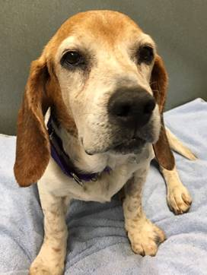
  Saturdays
  Open House Adoption
  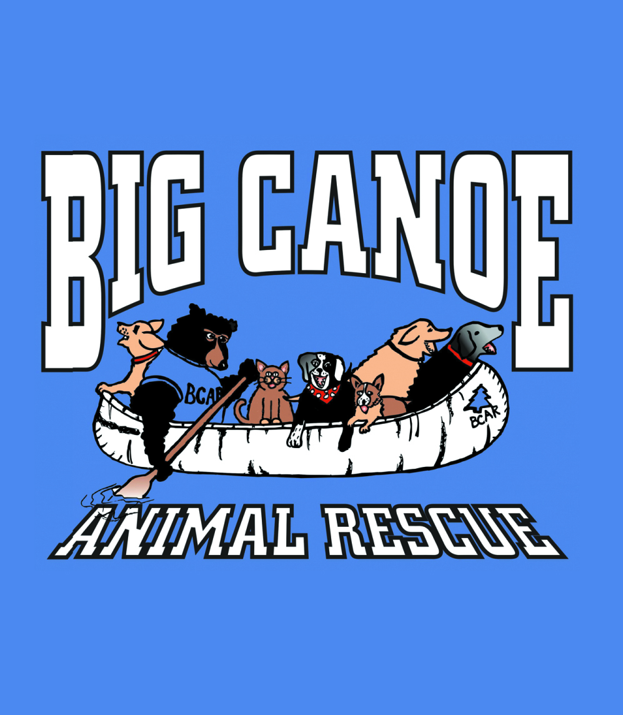
  11:00 to 1:00
  Big Canoe Animal Rescue
  Come in and meet the animals
  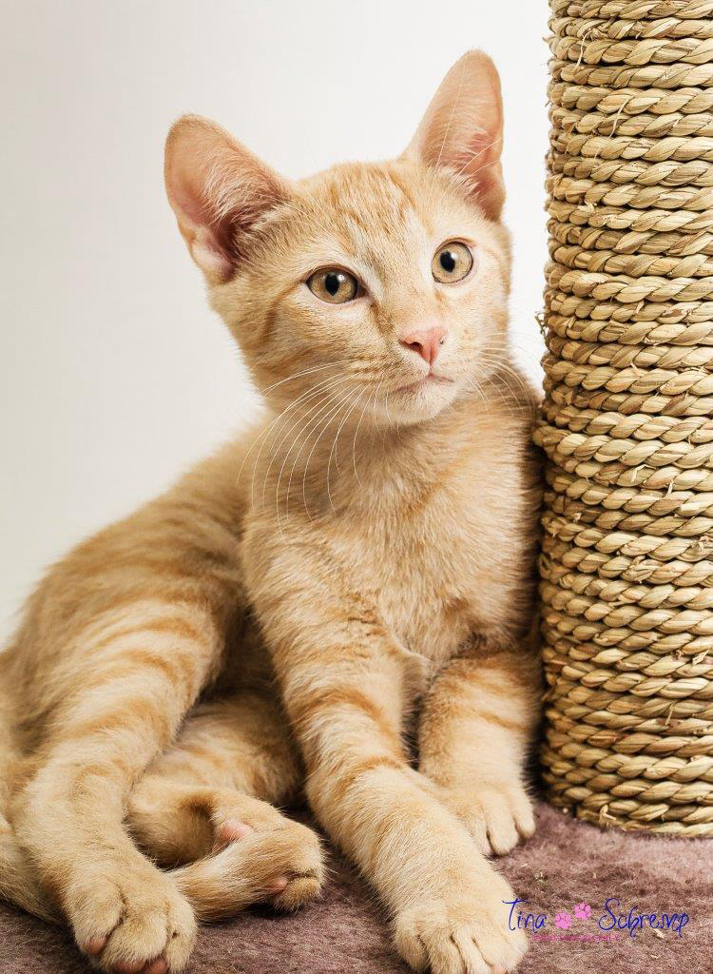
  Saturdays 11:00 to 1:00
  11:00 to
  [You Have Room for Another One Here!]
  Big Canoe Animal Rescue
  7506 Wilderness Parkway Big Canoe, GA, 30143 | 706-268-1346
  http://www.bigcanoeanimalrescue.org/
  Saturdays 11:00 to 1:00

